LibSpace - A Robust Backend for Library Operations

Thunder Client API Testing Results
This section demonstrates the testing of REST APIs using Thunder Client in VS Code. The following screenshots show successful API execution and MongoDB database updates.

1. User registration output (POST)
API Endpoint: http://localhost:5000/api/authuser/register
Method: POST
Status: 200 Created
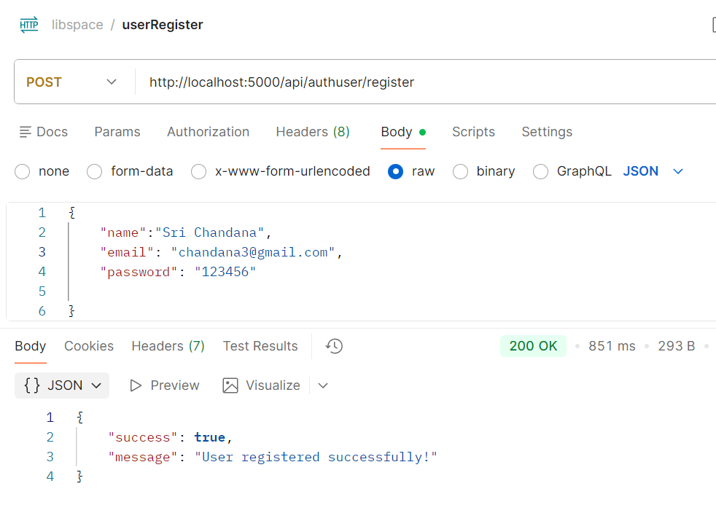

2. User Login Output (Post)
API Endpoint: http://localhost:5000/api/authuser/login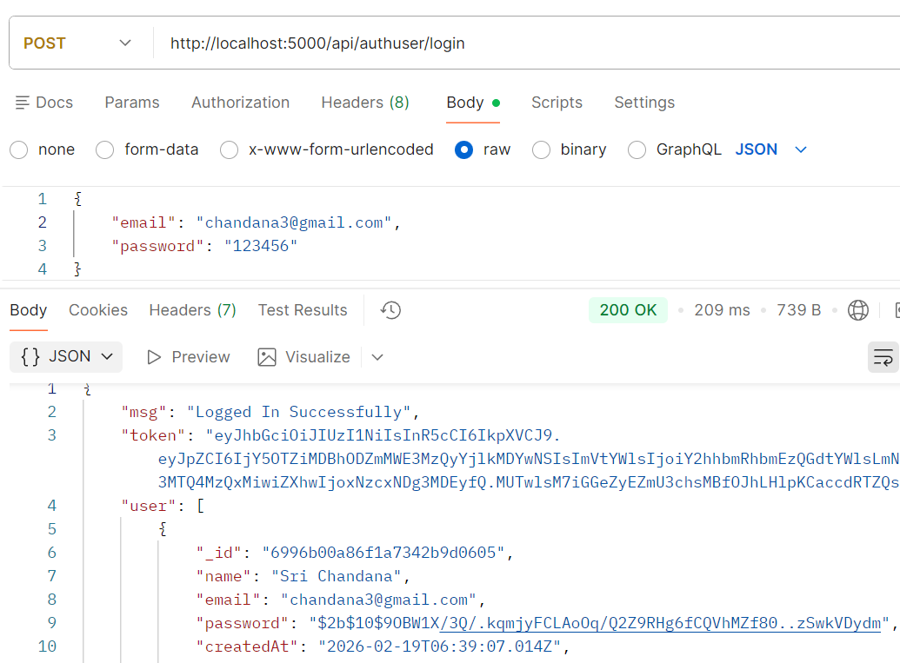
Method: PUT
Status: 200 OK
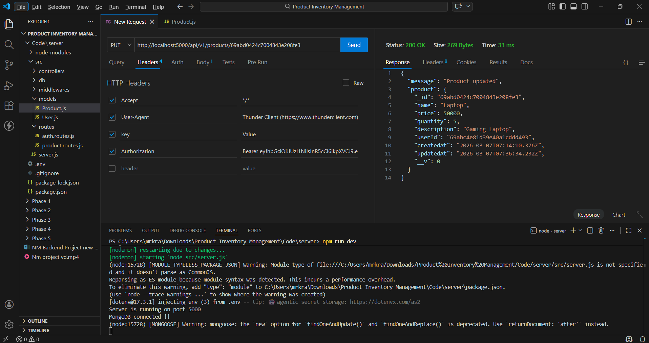

3. Adding Book (Post)
API Endpoint: http://localhost:5000/api/book/addbook
Status: 200 OK

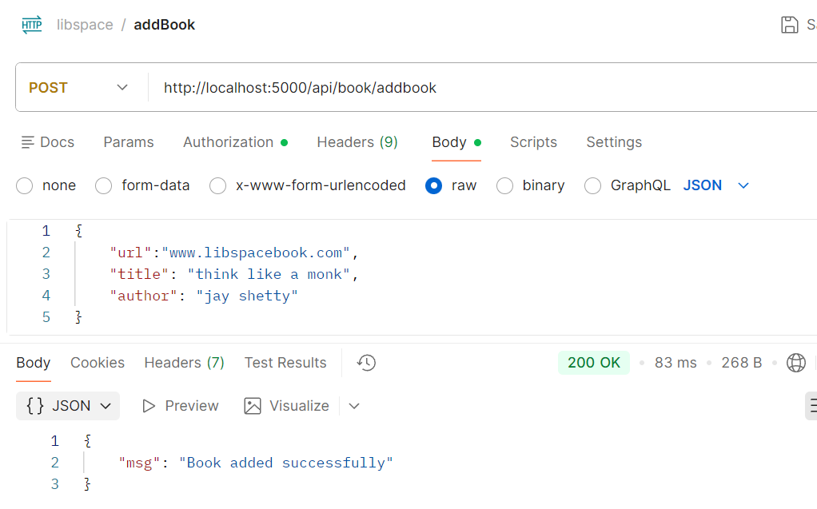4. Get All books (Get)
API Endpoint: http://localhost:5000/api/book/getbooks
Status: 200 OK
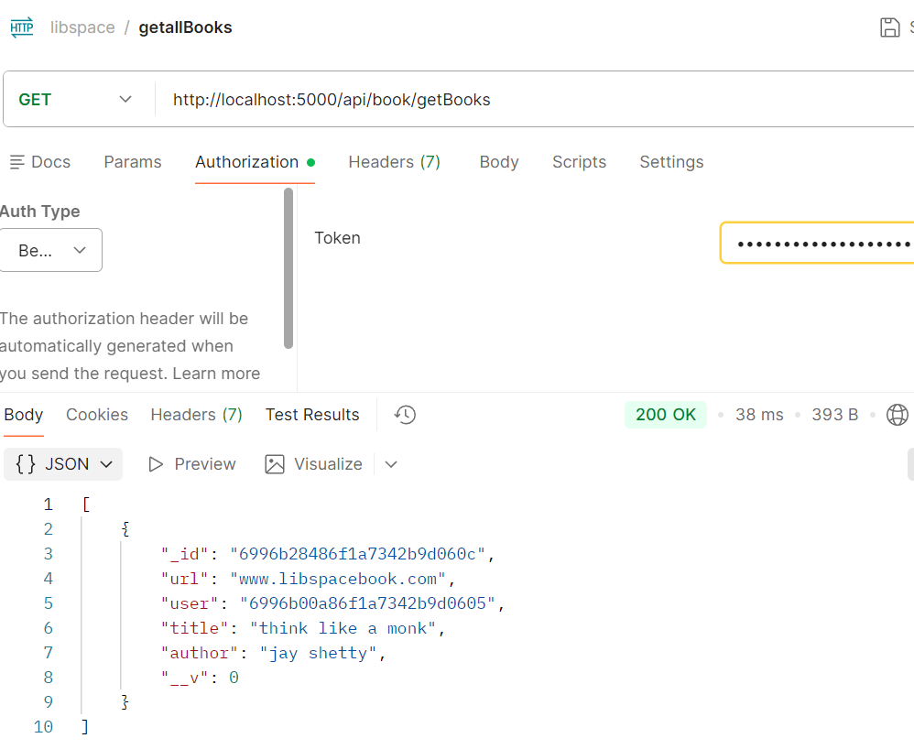
5. Get book by ID (Get)
API Endpoint:http://localhost:5000/api/book/6996b28486f1a7342b9d060c
Status: 200 OK
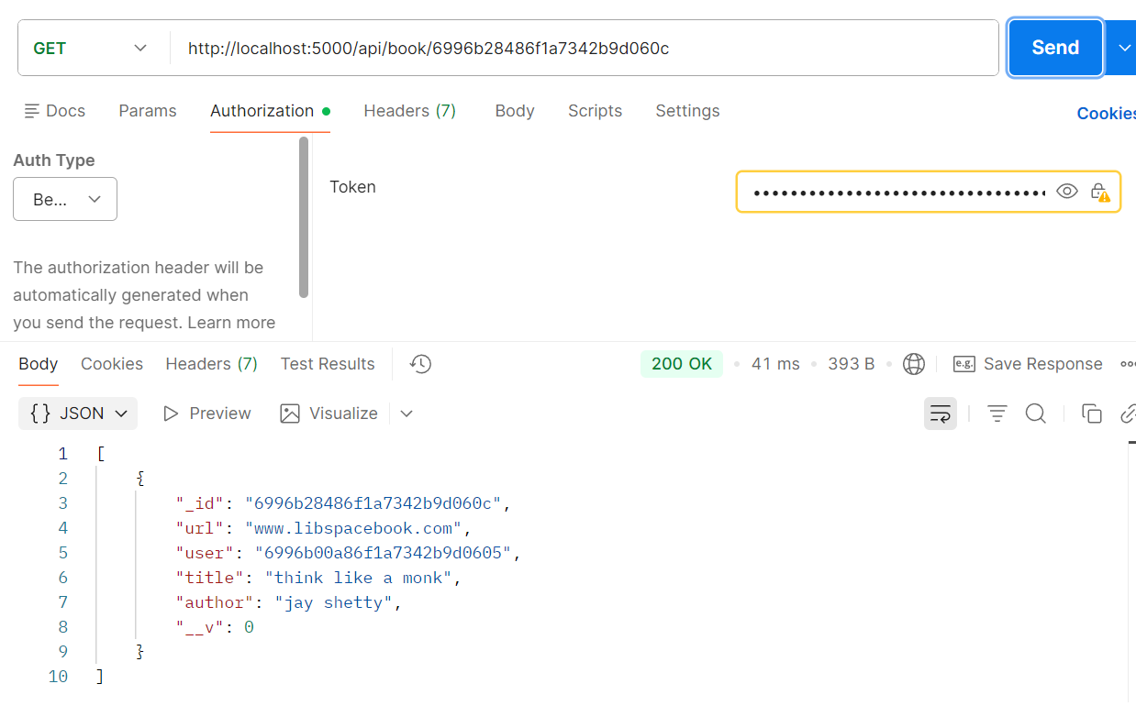
6. Update book (put)
API Endpoint:http://localhost:5000/api/book/6996b28486f1a7342b9d060c
Status: 200 OK
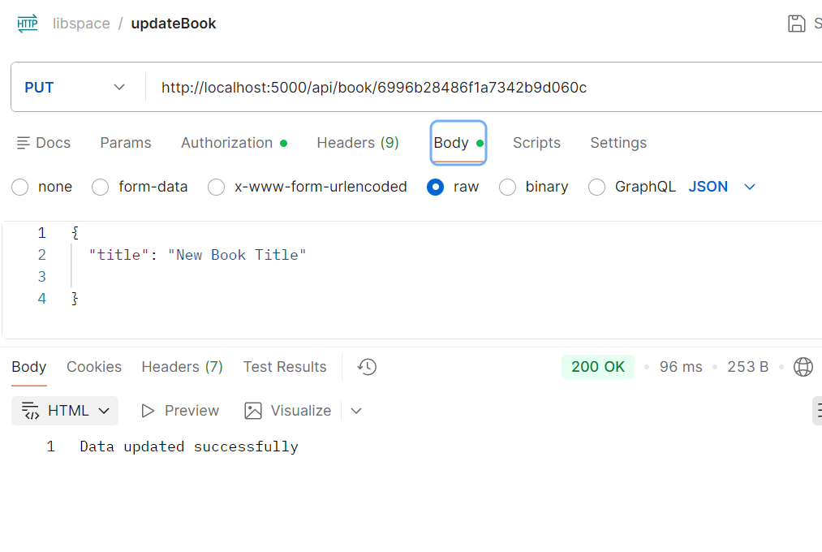
7.Delete book (Delete)
API Endpoint:http://localhost:5000/api/book/6996b28486f1a7342b9d060c
Status: 200 OK
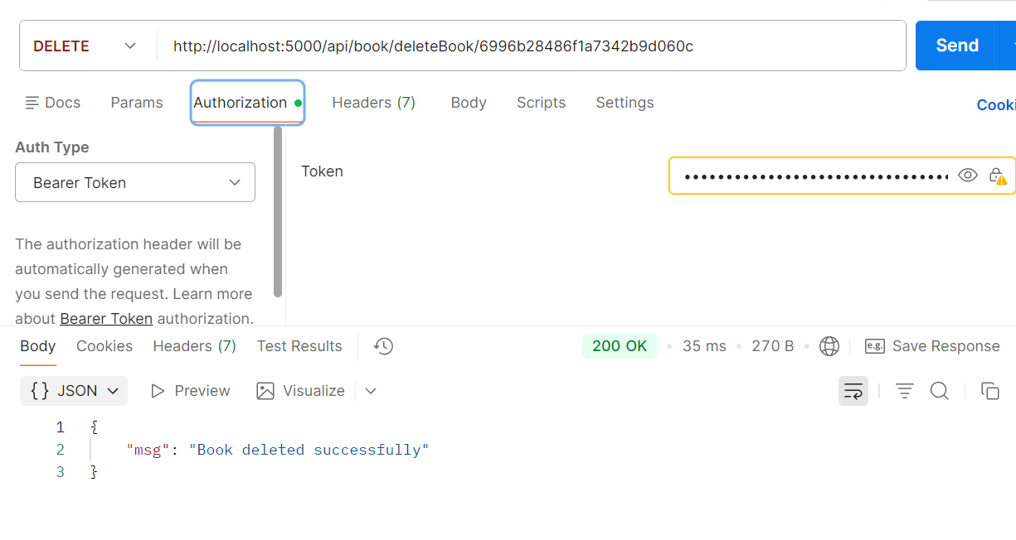

8. User Logout (Post)
API Endpoint:http://localhost:5000/api/authuser/logout
Status: 200 OK
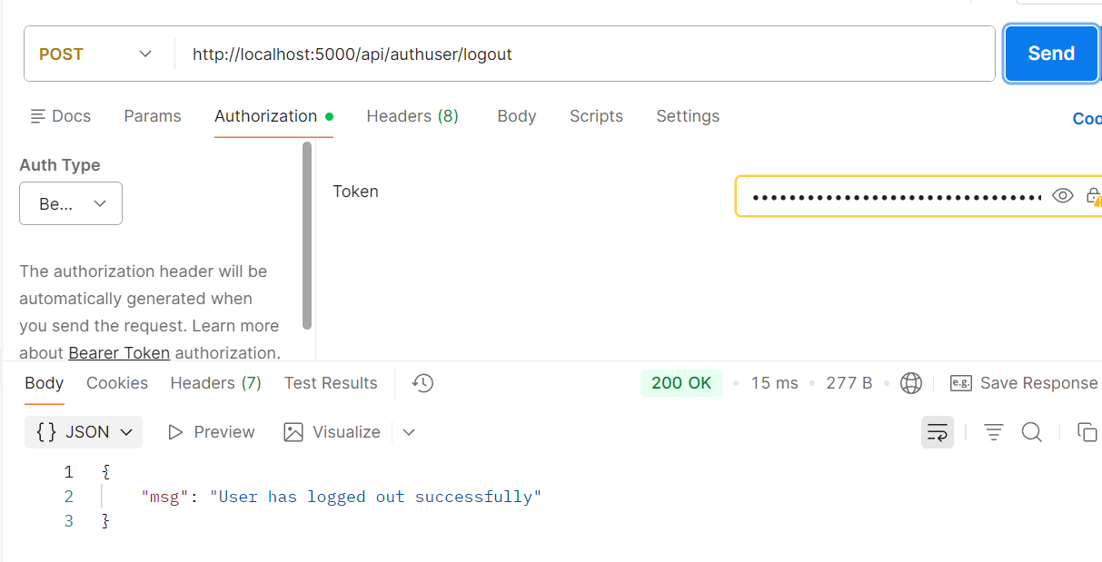

MongoDB Database – Products Collection
The following screenshot shows the stored product data in MongoDB Compass after performing API operations.
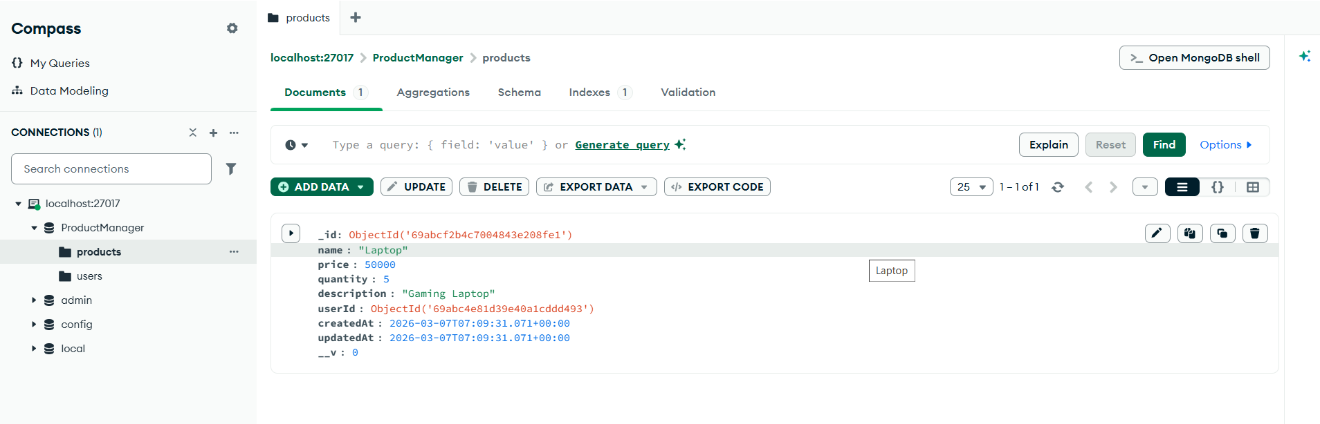

9. MongoDB Database – Users Collection
This screenshot displays the registered user stored in the MongoDB users collection.
